 | TITLE: | Lift Plan For C^ On Spit
6141 Appendix T5 Jefferson Lab Lift Plan Form |  |  | 
Instructions:
This form must be completed for each lift using a mobile crane, or a critical lift, with an overhead crane and/or forklift.
This form should be used for a non-routine lift with overhead cranes or incorporated into a Temporary Operational Safety Procedure.
STEP 1 – Planning the Lift | Lift Title | Lift Plan For C^ On Spit
STEP 1 – Planning the Lift | Location: | ESB And TEDF |  |  |  |  |  |  |  |  | Lift Date: |  |  | 3/11/2015
STEP 1 – Planning the Lift | Lift Plan Prepared by: |  | Anderson |  |  |  |  |  |  |  |  |  |  | 3/9/2015
STEP 1 – Planning the Lift |  |  | Print |  |  |  |  |  |  |  |  |  |  | Date
STEP 1 – Planning the Lift | Lift Plan Approved by: |  | Tilles
STEP 1 – Planning the Lift |  |  | Print |  |  |  |  | Signature |  |  |  |  |  | Date
STEP 1 – Planning the Lift | JLab Work Coordinator: |  |  | Tilles
STEP 1 – Planning the Lift |  |  |  |  |  |  |  |  |  |  |  |  |  | Date
STEP 1 – Planning the Lift | DOE Lift Classification: |  |  |  | CRITICAL | x | PREENGINEERED PRODUCTION |  |  |  |  |  |  |  | ORDINARY
STEP 1 – Planning the Lift | Load Weight # 3,100 Lbs |  |  |  |  |  |  |  | Weight Determined By:  Equipment Manufacturers Data Plate  Rigger Estimate  Labeled Shipping Weight  x Dyno Measured
STEP 1 – Planning the Lift | Describe the Load:
STEP 1 – Planning the Lift | Cherenkov with Spit installed, 2 point pick and 2 point rotational control picks.
STEP 1 – Planning the Lift | Rigging Hardware Required*: List all items (size & load rating) to be used under the hook to accomplish the planned lift.
STEP 1 – Planning the Lift | Harrington 2 ton ChainFalls 4 ea  4- 360 deg lift rings ½ inch 2500 lb torque to specs  2 ea- 5/8 - 3 ¼ ton shackles (Crosby)  5 ea 3/4- 4 ¾ ton shackles “ “  2 ea 7/8 – 5 ½ ton shackles “ “  Slings  1 - 40” Web basket 3200lb  1-4 foot green choker 4200 lb
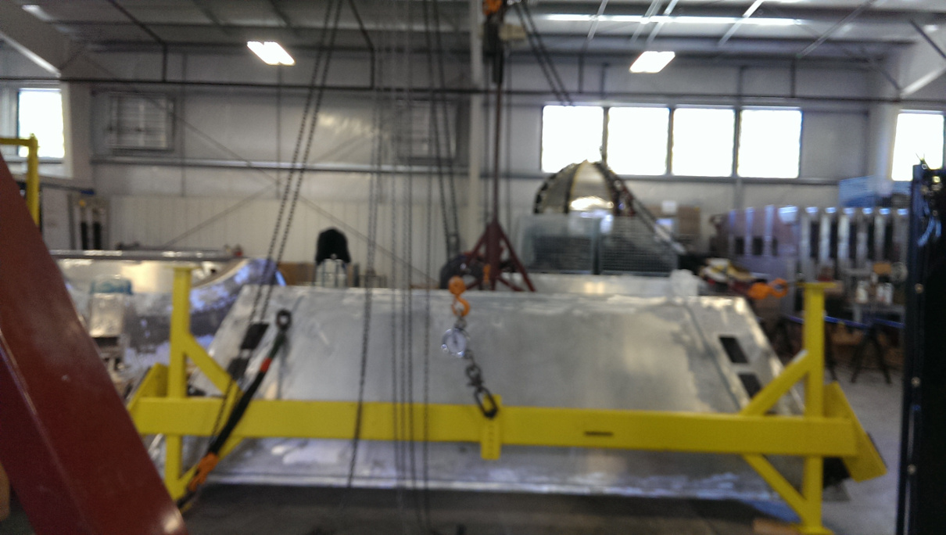
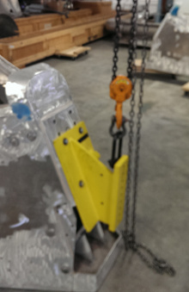

 | PLAN VIEW
STEP 1 – Planning the Lift | Show the Following:
STEP 1 – Planning the Lift | - Load with CG labeled  - Mobile Crane, Pivot and Outriggers  - Distance from load CG to Crane Pivot | - Underground Utilities, manholes and valve boxes  - Overhead Obstructions  - Lift Perimeter Demarcation
STEP 1 – Planning the Lift | 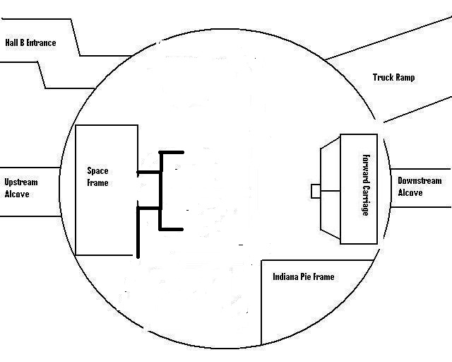

STEP 1 – Planning the Lift | ELEVATION
STEP 1 – Planning the Lift | Show the Following: | 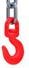
STEP 1 – Planning the Lift | - Load with CG labeled  - BTHLD’s  - Sling Horizontal Angels |  | - Sling Tensions  - Label Rigging Gear, size & WLL  - Label D/d ratios
STEP 1 – Planning the Lift | 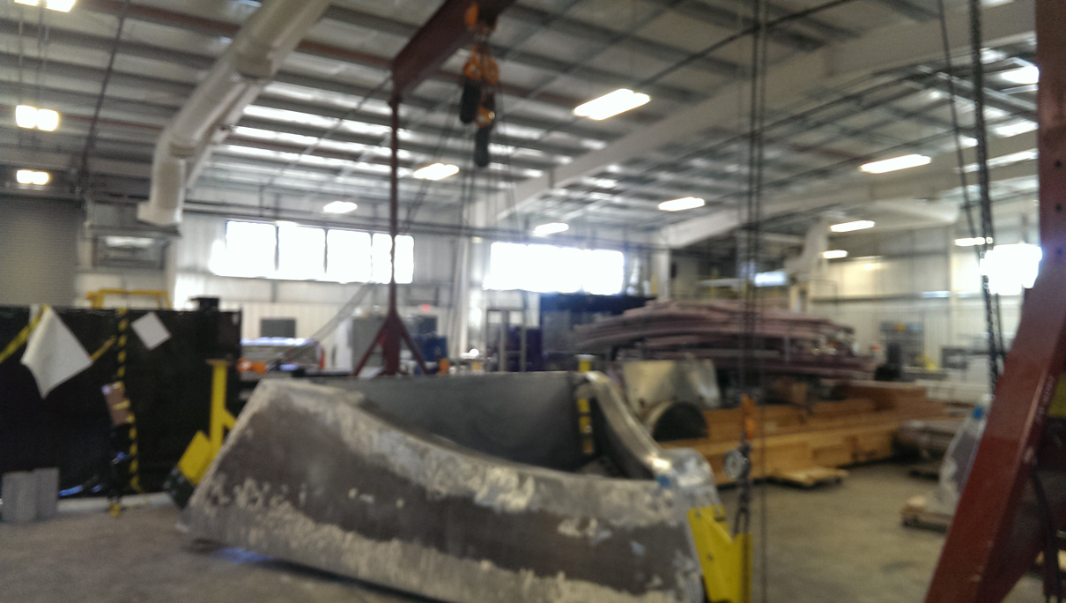  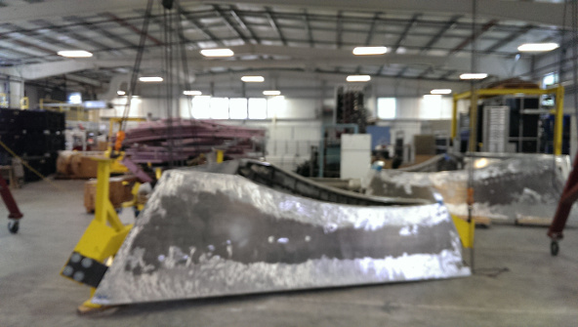

STEP 2 – Setup for Lift | Crane Make: |  | Strad-L-Load |  |  |  |  |  |  |  | Model: |  | 3-15-35R |  |  | Type: |  | 3 Ton Gantry
STEP 2 – Setup for Lift | Crane Owner |  | Jlab
STEP 2 – Setup for Lift | - Annually Inspection By: |  |  |  |  |  | Foley Crane |  |  |  |  |  |  |  | Date: |  | 12/2014
STEP 2 – Setup for Lift | - Daily Inspection Documented: |  |  |  |  |  |  |  | Yes No
STEP 2 – Setup for Lift | - Monthly Wire Rope Inspection Documented: |  |  |  |  |  |  |  |  |  |  | N/A
STEP 2 – Setup for Lift | - Quadrenial Proof Load Test Documented: |  |  |  |  | By:______________________________________ |  |  |  |  |  |  |  |  |  | Date:_____________
STEP 2 – Setup for Lift | Crane Operator |  |  |  | David Anderson
STEP 2 – Setup for Lift | - Certification/Qualification: |  |  |  |  |  |  | Overhead Crane Operator Qualification
STEP 2 – Setup for Lift | - CCO No: |  |  |  |  |  |  |  |  |  |  |  |  | Expiration Date: |  |  | 2016
STEP 2 – Setup for Lift | - Employer: | Jlab
STEP 2 – Setup for Lift | Lead Rigger: |  | David Anderson
STEP 2 – Setup for Lift | - Certification/Qualification: |  |  |  |  |  |  | Master
STEP 2 – Setup for Lift | Lift Director (ASME) or PIC (DOE): |  |  |  |  |  |  |  |  | David Anderson
STEP 2 – Setup for Lift | Site Supervisor: |  |  |  | David Anderson
STEP 2 – Setup for Lift | - Establishes a perimeter that clearly identifies the area of the lift.  - Ensures all personnel within the perimeter:  - Wear hard hat, safety shoes, safety glasses and any additional PPE required for the area.  - Attend the Pre-Lift Meeting.  - Conducts a Pre-Lift Meeting where the sequence of actions that will occur to accomplish the lift are presented.
STEP 2 – Setup for Lift | Signal Person: Morgan Cook___________________________________________________________
STEP 2 – Setup for Lift | PPE Requirements:  - Hard Hat  - Safety Shoes  - Safety Glasses |  |  |  | - List Additional Requirements:
STEP 2 – Setup for Lift | Watch Personnel:  (Maintains lift Perimeters) |  |  | Morgan Cook
STEP 2 – Setup for Lift | Identify a Muster Point:

STEP 2 – Setup for Lift | Emergency Procedure (In case of injury)
STEP 2 – Setup for Lift |  | - Stop Lift  - Lower Load to a safe position
STEP 2 – Setup for Lift |  | Limits of Safe Operation (Example: Wind, Rain, Lighting, Traffic)
Step 3 - Lift | Accomplish the lift according to the Lift Plan.  Document minor adjustments required to accomplish the lift.
Step 4 – Post-Lift Actions | Post Lift De-Brief
Step 4 – Post-Lift Actions |  | What went well:
Step 4 – Post-Lift Actions |  | Suggested Improvements:
Step 4 – Post-Lift Actions | Documentation - Send a Copy of this Completed Lift Plan to:
Step 4 – Post-Lift Actions | Name:
Step 4 – Post-Lift Actions |  |  | Print |  | E-Mail |  | Mail Stop



 | ISSUING AUTHORITY | TECHNICAL  POINT-OF-CONTACT | APPROVAL DATE | EFFECTIVE DATE | EXPIRATION DATE | REV.
 | ESH&Q Division | Dave Kausch | 04/12/10 | 04/12/10 | 04/12/13 | 1
This document is controlled as an on line file. It may be printed but the print copy is not a controlled document. It is the user’s responsibility to ensure that the document is the same revision as the current on line file. This copy was printed on 11/7/2026.

* Rigging Hardware must be inspected and marked in accordance with the criteria contained in the following documents: ASME B30.9 Slings ASME B30.20 Below the Hook Lifting Devices ASME B30.26 Rigging Hardware 29 CFR 1926.251 Rigging Equipment for Material Handling ? Excerpts from ASME B30.5-2007 5-3.1.3 Responsibilities While the organizational structure of various projects may differ, the following roles are described here for purposes of delineating responsibilities. All responsibilities listed below shall be assigned in the work site organization. (A single individual may perform one or more of these roles.
Crane Operator: directly controls the crane’s functions.
Lift Director: directly oversees the work being performed by a crane and the associated rigging crew. This position equates to the Person-In-Charge (PIC) identified in the DOE Hoisting & Rigging Standard.
Site Supervisor: exercises supervisory control over the work site on which a crane is being used and over the work that is being performed on that site.

